

**CSC 1300 LAB 10**

**Pastry Chef Competition**

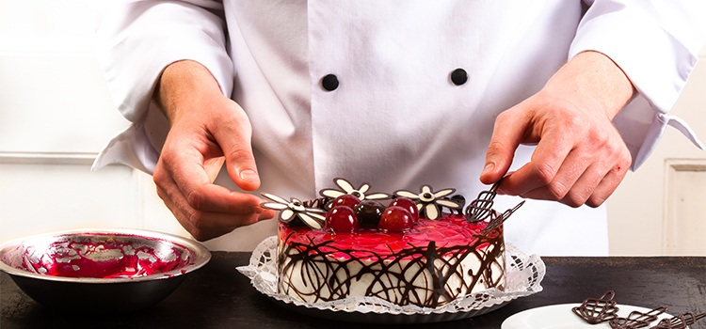

# New Concepts

* Structures
* Array of Pointers
* Dynamic Memory Allocation

# PAIRED PROGRAMMING ASSIGNMENT

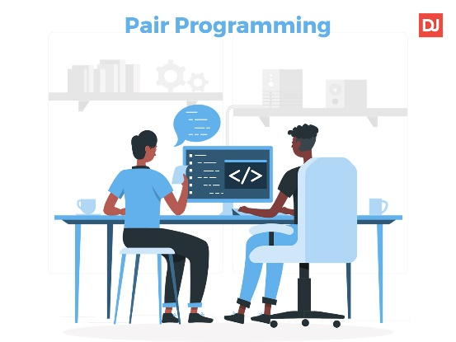**On this assignment, you will be allowed to work with ONE other person!**   
In the comment block at the top of your source file, you must place both names beside “Author: “ to indicate who you worked with. You can’t work with more than one other person. However, you may work alone if you wish.

During paired programming, one person serves as the “**Driver**” and the other serves as the “**Navigator**”. The Driver is the person at the wheel, i.e. the keyboard. They are focused on completing the tiny goal at hand, ignoring larger issues for the moment. A driver should always talk through what they are doing while doing it. The Navigator is in the observer position, while the driver is typing. They review the code on-the-go, give directions and shares thoughts. The navigator also has an eye on the larger issues, bugs, and makes notes of potential next steps or obstacles. The navigator can also help by looking up functions or syntax on reference websites, zyBooks, lecture slides, or example programs given in class.

# Description

Your program should allow the user to enter in how many pastry chefs are in a competition. Then, you will ask for each chef’s name, hometown, and how many categories the chef has won awards in. Then you will ask for each pastry category what the category name is and how many awards that chef won.

Then, you will print out which chef has the most awards (and print the chef’s name) and also list the categories (and number of awards) that the chef has won awards in. Refer to sample output if this description is unclear.

# Specifications

1. In your **CSC1300LAB** folder, create a **Lab10** folder.
2. Open **Visual Studio Code (VS Code)**.
3. Click on **File** and then select **Open Folder**. Select the folder that you just created.
4. Create a source file named **yourusername_lab10.cpp**.
5. Make sure to put a comment block at the top of your code with the filename, author (you & your partner or just you), date, and purpose of the program. Also make sure to put in comments to identify major sections of your code.
6. Create a **PastryCategory** structure. The members in this structure should be a string to hold the category name and an integer that should hold the number of awards.
7. Create a **Chef** structure which should contain two strings (name & hometown) and one integer (numCategories).
8. In the main function, ask how many chefs are competing and read that in to an integer variable. 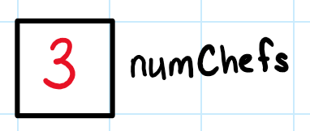
9. Dynamically allocate an array of **Chef** elements based on the number of chefs you just read in.

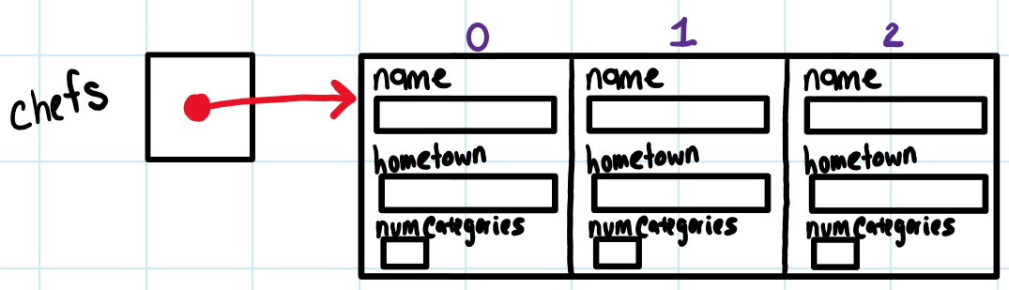

1. Dynamically allocate an array of **pointers-to-PastryCategory** based on the number of chefs you just read in.

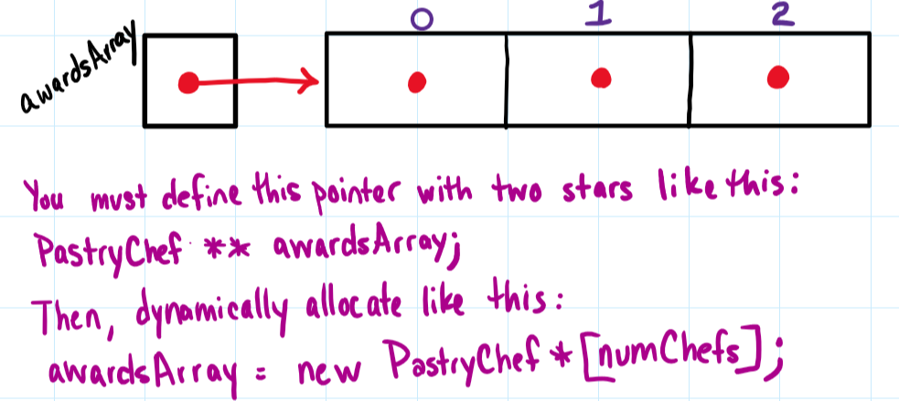

1. Allow the user to enter in information about each chef and fill up the appropriate array.
   * The chef’s name and hometown should be able to contain spaces. The player’s name, hometown, and number of categories they won awards in should go in the **Chef** array.   
     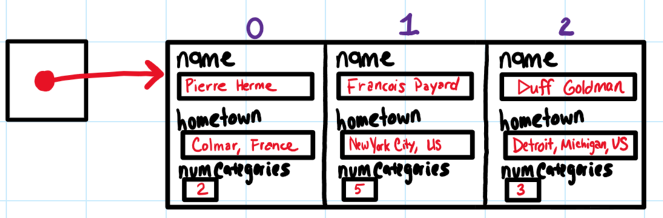
   * You will have to dynamically allocate an array of **PastryCategory** for each chef based on the **number of categories** they enter. Then, allow the user to enter in the category name and number of awards for each category.  
     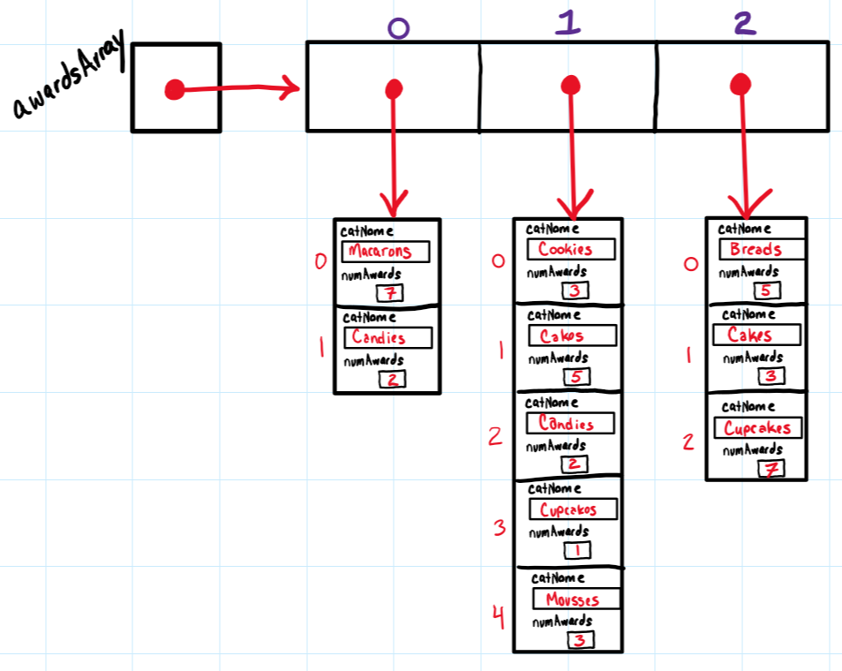



1. Calculate & print out the most awards earned by a chef.
   * You will need to add up (for each chef) the total number of awards earned in order to determine which chef earned the most awards.
   * Refer to the sample output to see what results you are supposed to print out and the formatting.
   * You may want to use the **numeric_limits** class **#include <limits>** to initialize the most hours variable to **std::numeric_limits<int>::min()**before the loop to find out who has the most awards.
2. For the chef that won the most awards, print out the award categories & the number of awards in each category as well. (Refer to sample output)
3. Don’t forget to release ALL dynamically allocated arrays!! You will need a for loop to iterate through the awards array in order to first delete all the dynamically allocated arrays pointed to by this awards array. Then, you can delete the awards array. Last, you can delete the chefs array.

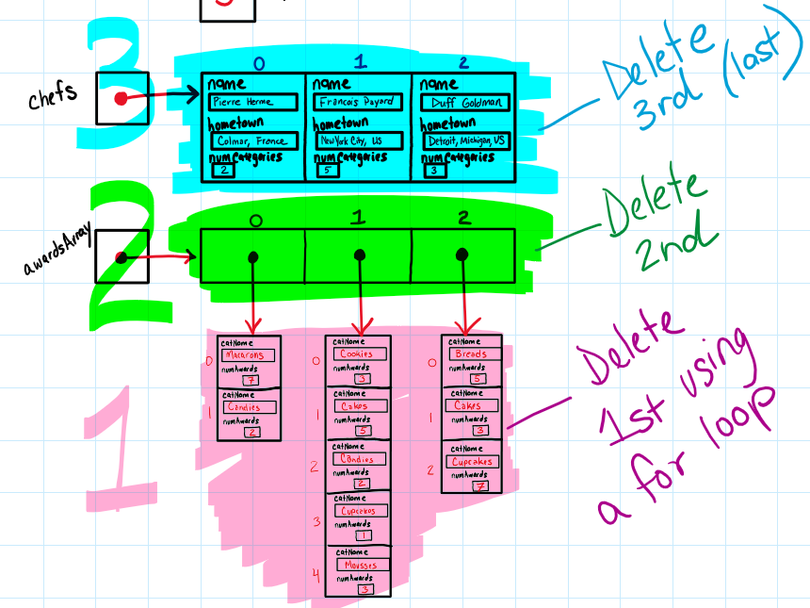

# Sample Output

User input is highlighted in **yellow** in the sample output below.

How many chefs are competing? 3

Please enter in information about each chef.

****CHEF 1****

NAME: Pierre Herme

HOMETOWN: Colmar, France

How many categories has Pierre Herme won awards in? 2

FOR CATEGORY 1:

Name of category - Macarons

Number of awards in Macarons - 7

FOR CATEGORY 2:

Name of category - Candies

Number of awards in Candies - 2

****CHEF 2****

NAME: Francois Payard

HOMETOWN: New York City, NY, US

How many categories has Francois Payard won awards in? 5

FOR CATEGORY 1:

Name of category - Cookies

Number of awards in Cookies - 3

FOR CATEGORY 2:

Name of category - Cakes

Number of awards in Cakes - 5

FOR CATEGORY 3:

Name of category - Candies

Number of awards in Candies - 2

FOR CATEGORY 4:

Name of category - Cupcakes

Number of awards in Cupcakes - 1

FOR CATEGORY 5:

Name of category - Mousses

Number of awards in Mousses - 3

****CHEF 3****

NAME: Duff Goldman

HOMETOWN: Detroit, Michigan, US

How many categories has Duff Goldman won awards in? 3

FOR CATEGORY 1:

Name of category - Breads

Number of awards in Breads - 5

FOR CATEGORY 2:

Name of category - Cakes

Number of awards in Cakes - 3

FOR CATEGORY 3:

Name of category - Cupcakes

Number of awards in Cupcakes - 7

The pastry chef who has won the most awards (15 awards) is Duff Goldman, with awards in the following categories:

Breads (5)

Cakes (3)

Cupcakes (7)